 | ASOCIAȚIA DE DEZVOLTARE INTERCOMUNITARĂ  BUCUREȘTI – ILFOV | 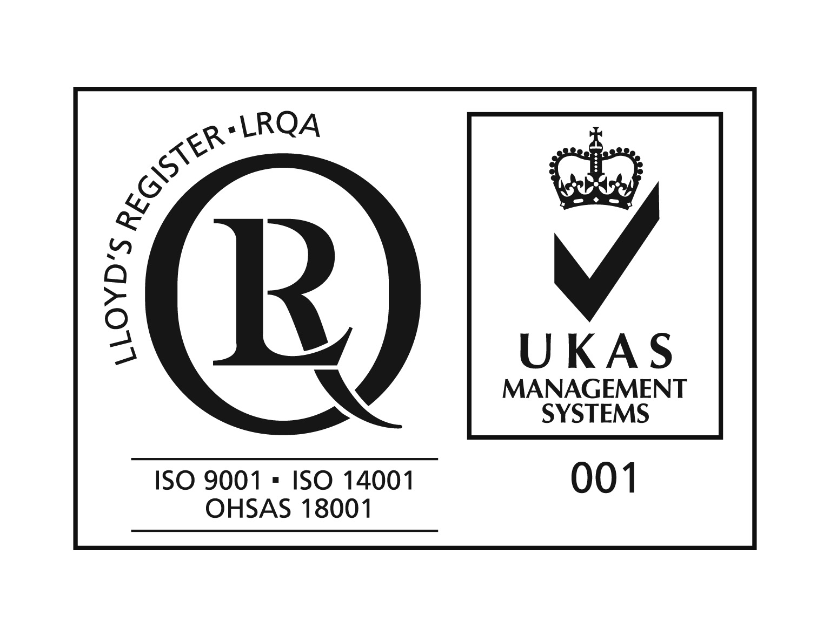

Dear all,

Bucharest-Ilfov Intercommunity Development Association (ADIBI) is searching to join projects under INTERREG EUROPE Programme regarding the following topics: natural and cultural heritage, air pollution/quality, traffic congestion, mobility within a metropolitan area, energy efficiency, renewable energy, water management.

In case you are interested please contact:
Mr. George OANCEA
Head of Strategy and Project Development Department
+40 21 318 01 13
george.oancea@adibi.ro
www.adibi.ro

Short description of Bucharest-Ilfov Intercommunity Development Association (ADIBI)

ADIBI has been established in 2008 in order to help development of Bucharest Ilfov Region and aims to: provide, administrate and develop the cooperation and partnership between the Bucharest City Hall, Ilfov County Council and the County`s localities and other regions, internal and international bodies; to offer information and to present the opportunities about domestic and abroad cooperation with to all interested institutions or individuals; to elaborate eligible projects; to obtain information about the non-reimbursable EU funds to be used for the implementation of a.m. projects.
Associated members are both administrative territorial units of Bucharest – Ilfov Region:
- The Municipality of Bucharest – through General Council of Bucharest represented by the Mayor.
- Ilfov County – through the Ilfov County Council represented by the President of the County Council.
The organizational structure of ADIBI is made up of 5 specialized compartments that assure the fulfilment of the tasks in each activity domain.
The total number of employees is 14 civil servants, out of which one director.

The budgetary resources of ADIBI are provided from the budget of both associated members and European projects funding.
The purpose of the association is to prepare and promote at all levels, regional development projects that are of common interest for the two territorial and administrative units, in the field of social services, transportation, environment, tourism, innovation, cultural and the business environment. The association also gets involved in obtaining the internal and external financing necessary for the implementation of such projects, in order to implement development projects important at local or regional level, or in order to supply public services and buy equipment for the emergency intervention services/ inspectorates.
ADIBI is member of Magurele High Tech Cluster Project –MHTC – which is a prerequisite for opportunities created by the ELI – NP project for not being wasted due to undeveloped fast enough and sustainable private sector and lack of resources for successfully positioning cluster entities components; product / service innovation generated international markets.
http://www.mhtc.ro/en/

Măgurele Science Park (MSP ) is a socio- economic platform type business incubator that aims primarily at providing opportunities for development of entrepreneurial environment in rural and urban areas of Ilfov county. Initiative MSP scientific and technological park belongs to Ilfov County Council, A.D.I.B.I, Horia Hulubei National Institute for R%D in Physics and Nuclear Engineering (IFNN-HH) and City Hall Magurele and is supported by all local entities, regional, governmental, research institutes Magurele, but also by business type high tech.

ADIBI staff has major experience in the coordination of European projects and partnerships, projects financed by national government, development of project applications, financial management of projects, cross-border cooperation, organization of conferences and seminars financed under different EU Programs.
These projects were financed by 2007 -2013 Regional Operational Programme, South East Europe Programme, INTERREG IV C, Increase of Economic Competitiveness (SOP-IEC), Sectoral Operational Programme PHARE, national funding and were related to developing the social infrastructure, emergency interventions infrastructure, environment, regional development, innovation among the young entrepreneurs.

Finalized projects:

- Developing and equipment of the Professional Services for Emergency Situations in the BUCHAREST – ILFOV Region - financing by EU, ROP 2007 -2013 Programme, 10 mil euro, buying profesional equipments for the Regional emergency intervention services;
- Developing and equipment of the Specialized Services for Emergency Situations in the BUCHAREST – ILFOV Region, part 2 - financing by EU, ROP 2007 -2013 Programme, 4 mil euro, buying profesional equipments for the Regional emergency intervention services ;
- Improving the equipment of the operational headquarters for emergency situation interventions in the BUCHAREST – ILFOV Region, part 3 - financing by EU, ROP 2007 -2013 Programme, 4 mil euro, buying profesional equipments for the Regional emergency intervention services;

- SEE -INNOVA - financing by EU, South East Europe Programme, promoting innovation among young researchers for elderly people active assisted living;
- EnVision 2020 - financing by EU, South East Europe Programme, environment, undertaking foresight activities focusing on energy resources consumption ;
- Dissemination and communication campaign for Bucharest – Ilfov Sustainable Urban Mobility Plan;
- Strategic Environmental Assessment (SEA) and Environmental Management Plan for Bucharest – Ilfov Sustainable Urban Mobility Plan.

